**Atliq Hardware**



By: Priyam Jain

Requests:

1. Provide the list of markets in which customer "Atliq Exclusive" operates its business in the APAC region.

Answer:

SELECT

distinct market

FROM dim_customer

where customer = "Atliq Exclusive"

and region = "APAC";

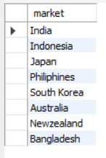

2. What is the percentage of unique product increase in 2021 vs. 2020? The final output contains these fields, unique_products_2020 unique_products_2021 percentage_chg.

Answer:

WITH unique_products AS (

SELECT

fiscal_year,

COUNT(DISTINCT product_code) AS unique_products

FROM fact_sales_monthly

WHERE fiscal_year IN (2020, 2021)

GROUP BY fiscal_year

)

SELECT

MAX(CASE WHEN fiscal_year = 2020 THEN unique_products END) AS unique_products_2020,

MAX(CASE WHEN fiscal_year = 2021 THEN unique_products END) AS unique_products_2021,

round((MAX(CASE WHEN fiscal_year = 2021 THEN unique_products END) - MAX(CASE WHEN fiscal_year = 2020 THEN unique_products END)) * 100.0 /

MAX(CASE WHEN fiscal_year = 2020 THEN unique_products END), 2) AS percentage_chg

FROM

unique_products;

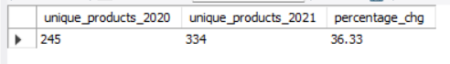

3. Provide a report with all the unique product counts for each segment and sort them in descending order of product counts. The final output contains 2 fields, segment product_count

Answer:

select

segment,

count(distinct(product_code)) as product_count

from dim_product

group by segment

order by product_count desc;

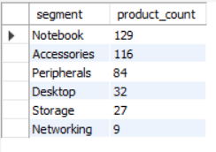

4. Follow-up: Which segment had the most increase in unique products in 2021 vs 2020? The final output contains these fields, segment product_count_2020 product_count_2021 difference

Answer:

WITH unique_products AS (

SELECT

dim_product.segment,

fiscal_year,

COUNT(DISTINCT product_code) AS unique_products

FROM fact_sales_monthly join dim_product using (product_code)

WHERE fiscal_year IN (2020, 2021)

GROUP BY dim_product.segment, fiscal_year

)

SELECT

segment,

MAX(CASE WHEN fiscal_year = 2020 THEN unique_products END) AS product_count_2020,

MAX(CASE WHEN fiscal_year = 2021 THEN unique_products END) AS product_count_2021,

(MAX(CASE WHEN fiscal_year = 2021 THEN unique_products END) - MAX(CASE WHEN fiscal_year = 2020 THEN unique_products END)) AS difference

FROM

unique_products

group by segment;

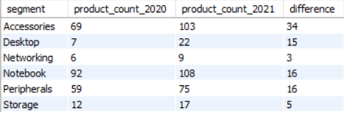

5. Get the products that have the highest and lowest manufacturing costs. The final output should contain these fields, product_code product manufacturing_cost

Answer:

WITH manufacturing_costs AS (

SELECT

dp.product_code,

dp.product,

fmc.manufacturing_cost,

RANK() OVER (ORDER BY fmc.manufacturing_cost DESC) AS rank_highest,

RANK() OVER (ORDER BY fmc.manufacturing_cost ASC) AS rank_lowest

FROM dim_product dp

JOIN fact_manufacturing_cost fmc

ON dp.product_code = fmc.product_code

)

SELECT

product_code,

product,

round(manufacturing_cost, 2)

FROM manufacturing_costs

WHERE rank_highest = 1 OR rank_lowest = 1;

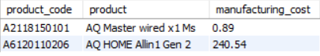

6. Generate a report which contains the top 5 customers who received an average high pre_invoice_discount_pct for the fiscal year 2021 and in the Indian market. The final output contains these fields, customer_code customer average_discount_percentage

Answer:

select

customer_code,

c.customer,

ROUND(pre_invoice_discount_pct*100,2) AS average_discount_percentage

from fact_pre_invoice_deductions

join dim_customer c using(customer_code)

where pre_invoice_discount_pct >

(select avg(pre_invoice_discount_pct) as average_discount_percentage

from fact_pre_invoice_deductions

where fiscal_year = 2021)

and fiscal_year = 2021

and c.market = "India"

ORDER BY pre_invoice_discount_pct DESC

LIMIT 5;

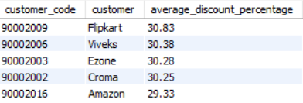

7. Get the complete report of the Gross sales amount for the customer “Atliq Exclusive” for each month. The final report contains these columns: Month Year Gross sales Amount

Answer:

select

month(sm.date) as Month,

year(sm.date) as Year,

round(sum(sm.sold_quantity*gp.gross_price)) as Gross_Sales_Amount

from fact_sales_monthly sm

join fact_gross_price gp

on sm.product_code = gp.product_code

and sm.fiscal_year = gp.fiscal_year

join dim_customer c

on sm.customer_code = c.customer_code

where c.customer = "Atliq Exclusive"

group by sm.date

order by Year and Month asc;

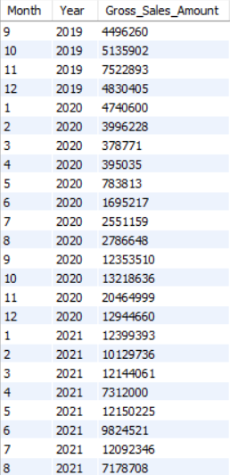

8. In which quarter of 2020, got the maximum total_sold_quantity? The final output contains these fields sorted by the total_sold_quantity, Quarter total_sold_quantity

Answer:

SELECT

quarter(DATE_ADD(date, INTERVAL 4 MONTH)) AS quarter, sum(sold_quantity) AS

total_sold_quantity

FROM fact_sales_monthly

WHERE fiscal_year = 2020

GROUP BY quarter ORDER BY total_sold_quantity DESC;

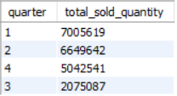

9. Which channel helped to bring more gross sales in the fiscal year 2021 and the percentage of contribution? The final output contains these fields, channel gross_sales_mln percentage

Answer:

with cte1 as

(select

c.channel,

round(sum(sm.sold_quantity*gp.gross_price)) as gross_sales_Mln

from fact_sales_monthly sm

join fact_gross_price gp

on sm.product_code = gp.product_code

and sm.fiscal_year = gp.fiscal_year

join dim_customer c

on sm.customer_code = c.customer_code

where year(date) = 2021

group by c.channel)

SELECT

channel,

gross_sales_mln,

ROUND(gross_sales_mln/(SELECT sum(gross_sales_mln) FROM cte1)*100) AS percentage

FROM cte1

ORDER BY percentage DESC;

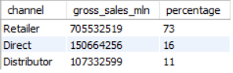

10. Get the Top 3 products in each division that have a high total_sold_quantity in the fiscal_year 2021? The final output contains these fields, division product_code product total_sold_quantity rank_order.

Answer:

with cte1 AS

(SELECT

division,

sm.product_code,

product,

sum(sold_quantity) AS total_sold_quantity

FROM fact_sales_monthly sm

JOIN dim_product p

ON sm.product_code=p.product_code

WHERE "2021"

GROUP BY p.product_code, p.division, p.product

ORDER BY p.division DESC, total_sold_quantity desc)

SELECT * FROM ( SELECT *, row_number() OVER(PARTITION BY division ORDER BY total_sold_quantity

DESC) AS rank_order FROM cte1)

RANKED

WHERE rank_order <= 3;

